Thank you for giving us the opportunity to submit a revised version of our manuscript to the Transportation Research Part A. In the enclosed documents, you will find the revised manuscript “Towards completely caring 15-minute neighbourhoods”.

We take this opportunity to thank the reviewers for their valuable comments that helped us to produce an improved version of the manuscript.

In the following paragraphs, you will find the detailed responses to each of the comments raised by each of the reviewers written in blue.

## Reviewer #1:

* Interesting and relevant research on the "caring" 15mC. Below points in order to improve the promising manuscript:

Thank you for your comprehensive revision. In the following paragraphs you will find detailed information on how your comments were considered.

* Line 51: Why only feminist geographers (which is correct, but not exclusive) and not human geographers as a whole?

Good point. We’ve changed the text to reflect this idea: *“An increasing number of human geographers, planners and other researchers agree that urban structure influences travel, but city planning falls short in planning for a neutral identity” (pg 2)*

* Line 55: A reference is missing indicated by the ?.

The “?” was an error and has been removed. Thanks for catching this.

* Line 74: For the reader who might not be in the field, it would be helpful to elaborate on the differences between gender equality and equity.

Thank you for bringing up this point. The distinction between the two terms may not be known by all, so briefly defining both is beneficial. We’ve added a footnote to the paper that explains this nuance as follows:

*The United Nations defines "gender equality" as equal rights, responsibilities, and opportunities for all genders, regardless of gender at birth[1]; they prefer "gender equality," as "equity" relates to the concept of fairness that are usually based on traditions, customs, or cultural beliefs which can perpetuate disadvantage. However, "equity," in the broader context of social justice, is widely accepted. As defined in the UNICEF Glossary of DEI terms, equity is the "process of being fair to all individuals and groups, by addressing present and historical inequality in order to work towards equality in outcomes" and may involve temporary special measures to address systemic discrimination faced by marginalized groups[2].*

* Line 236: 4. "Data" is misleading as it also incorporates 4.1. "Case study context" which introduces Hamilton. I would suggest renaming the chapter.

Thanks for raising this point. To ensure clarity for all, we updated the section title to “Case study and data”.

* Page 10, Fig. 1:"…per DA", what does DA stand for?

In our first instance of mentioning DA (at the start of the “Case study and data” section), we define the acronym: on page 9 *“We aggregated the points at the level of Canadian Census Dissemination Area (DA) along with the population and population per parcel plots in Figure 1.*” However, we see we did not explicitly explain what DAs *are*. We’ve added additional explanation following the one quoted to explain.

*“The DA is the most spatially granual level of publicly available Canadian census data. DAs are created by Statistics Canada for the purpose of the census and each represent between 400 to 700 people (Q1:442 and Q3:664 from Figure 1).”* (also page 9)

* Page 13, Fig. 3: Points are so tiny that the colors are hardly recognizable.

Good point. We’ve remade the figure by slightly increasing the point size (without making them too large as to completely cover too many neighbouring points) and changed the care destination ‘type’ to be distinguished by shape instead of colour (this may be more accessible). This version of the figure, we believe, more clearly communicates the locations of the destination data. We also increased the resolution of the figure, so the symbols edges are more crisp. We understand a static map for this point-specific data may not be the most ideal solution, but the intention of this figure is to demonstrate the location of the care destinations. While symbols may still overlap and appear small at 100% zoom, one can zoom in on the figure and further inspect the destinations. We also played around with different visualisation styles (e.g., aggregating the points (a heat map) for each destination type), but decided that just representing the locations of each point as simply as possible makes more sense for the “Case study and data” section, as the accessibility measure ultimately are ‘summaries’ of how those destinations can be accessed based on travel time. Furthermore, as also mentioned in the manuscript, the specific locations of the care destinations are freely available in the lead author’s Github repository associated with the manuscript.

We hope the new figure and thought process behind our decision is clearer now. For convenience, we’ve included the new figure below:

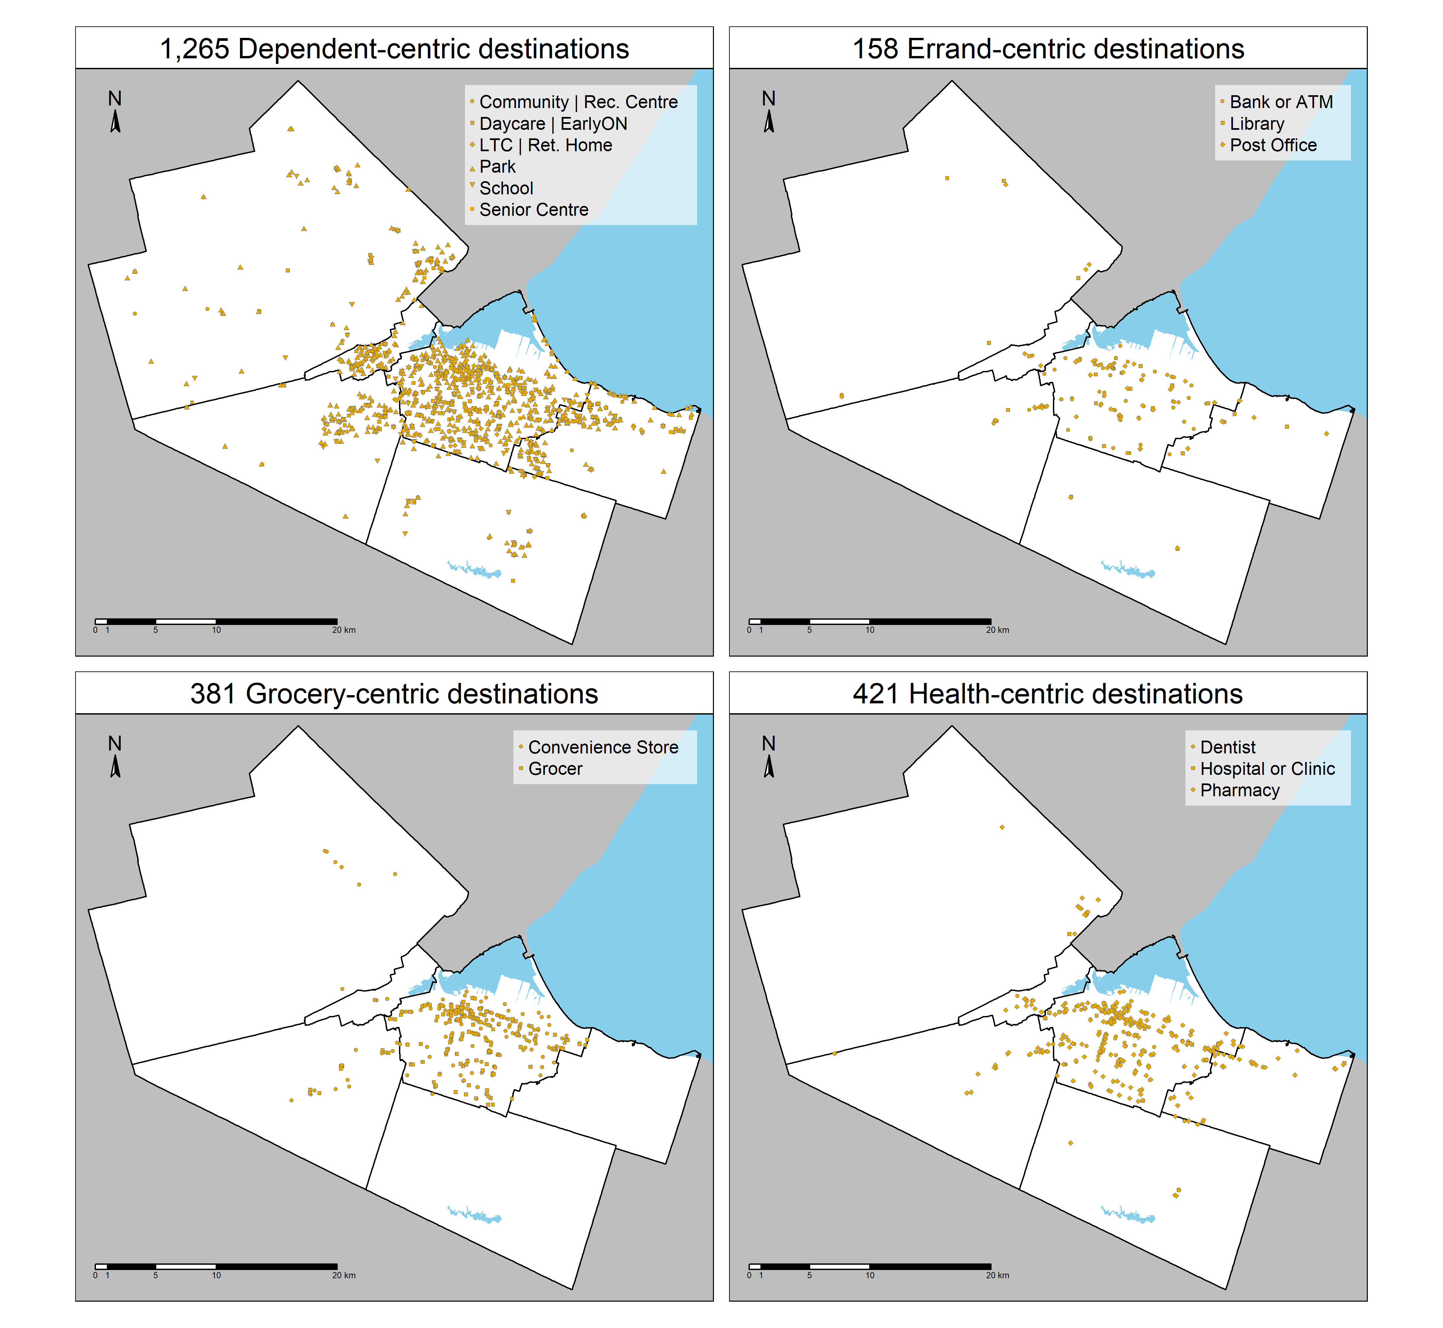

* Page 20: A more detailed description and analysis of the maps would be interesting for the reader. The methodological approach was very detailed described, but the results are not. Please also explain/stress the importance of superclusters ideally by giving concrete examples from Hamilton.

Thank you for raising this point! We’ve update the manuscript to add additional detail that adds additional Hamilton-specific context, specifically:

* We re-created Figure 4 and 5 to display values by quartile, so the top and bottom quartiles (the highest and lowest values) can be more easily discerned. Descriptions in the manuscript of the figures have also been modified to reflect this change.
* On pg 20-22, we elaborate the supercluster explanations by adding the proportion of urbanised, suburban, and rural land-use that correspond to each supercluster. This inclusion builds onto the previously present description referring to the summary Table 2 and Figure 7 quantifying the superclusters.
* Slightly enhanced the discussion about Figure 8, with additional references to the diversity scores and the proportion rural/suburban/urban.

We hope our enhanced discussion of the results is sufficient to satisfy your concerns.

* Page 24: Fig. 8: is placed in the middle of the text. Please rearrange.

Thanks for identifying this issue. The document was producing using LaTex and images are configuring image outputs in a template (for TRA) can result in the images placement being a bit off. We’ve corrected the placement.

* Page 27, Line 474 Hamilton is a city.

Thanks for catching this! We’ve corrected this typo, and others, in the revised manuscript. Appreciate it.

* Page 28, the gentrification issue is important to address. Maybe even giving some policy recommendations to limit the negative impacts.

Gentrification is an important topic, agreed. However, we elaborated on gentrification on the extent we did because unfortunately, the manuscript doesn’t explicitly touch on issues of gentrification as its primary objectives. For this reason, we can’t make explicit policy recommendation. But we do now add an additional sentence that this is an important issue that warrants its own investigation. Hopefully this addition to the manuscript and our justification satisfy your concern.

* Page 29, Line 534: methodology and typo

Thank you for pointing out this typo! It has been corrected.

* In general, the authors demonstrate their data-heavy approach can perform a scan on a "caring" 15mC score. However, a zoom in with more qualitative approaches (e.g. walk alongs with care givers, focus groups in order to learn about their actual needs) would give a more complete picture of the actual situation. Still, I am aware that this is not feasible to add, but it could be mentioned at the end as a need for further research.

Of course, excellent suggestion. We’ve expanded the final paragraph in the “Discussion” to underscore the need for additional qualitative and mixed methods research on this topic, as they can provide cohesive personal and lived perspectives of observed trends.

## Reviewer #2:

Thank you for your comprehensive review of the manuscript and all your positive comments. In the following paragraphs you will find detailed information on how your comments were considered and/or addressed in the revised manuscript.

1. Originality: Despite its acknowledged importance, the issue of "Mobility of Care" remains insufficiently explored in relationship with the "15-Minute City" concept, a gap filled by this current study. The novelty of this paper resides in its fortunate attempt to achieve two research objectives. Thus, the authors conduct an empirical examination of Hamilton, Canada, and contribute to the literature by bridging the above-mentioned concepts and creating a vivid image of what local amenities matter, but also a comprehensive picture of the socio-economic profiles of individuals who live in 15-minute caring neighbourhoods.

* We really appreciate this comment; we’re happy our objectives were clearly communicated in the manuscript.

2. Scientific Quality: From the scientific viewpoint, the manuscript's quality is indisputably convincing for many reasons. Firstly, the intersection of the "15-Minute City" concept with the "Mobility of Care" framework, with a focus solely on caregiving trips, is well-grounded in the authors' decision to address a vital yet often neglected aspect of transportation planning. In addition, the authors properly connect these frameworks and succeed in providing new perspectives on the urban planning implications for caregiving accessibility and gender equity.

Secondly, their methodological approach guarantees robust findings that are not only replicable but also adaptable to other urban areas similar to Hamilton, a mid-size city.

Thirdly, the results seem to be particularly important for urban policy and planning, because they identified areas that would benefit most from specific interventions.

Last but not least, I highly appreciate the paper's overall clarity, coherence, and relevance, as well as the academic tone of the writing which tends to be rather formal and makes use of tentative language and hedging.

* Thank you for this comment. From the beginning of manuscript drafting, we wanted to ensure the investigation of both “15-Minute City” and “Mobility of Care” concepts were relevant to transportation planning today. We also wanted to ensure the methodology and data, which is both complex and large, was carefully explained and the discussion of the results were always mediated by the limitations inherently associated with the methods. We’re happy to read that these efforts were not in vain, and you found these aspects notably positive.

3. Relevance to the Field(s) of this Journal: This manuscript demonstrates a high relevance to the field of transportation covered by this journal, due to its clear policy concern, but also because it is based on solid research and good-quality data.

* Thank you for this comment! Happy to hear we may have picked the right home for this manuscript.

4. General Comment: This paper represents an excellent contribution to the field of urban planning and mobility studies because the "Mobility of Care" concept is linked to the "15-Minute City" concept through a case study that explores the care destinations' accessibility in Hamilton, Canada. Moreover, authors employ machine learning approaches to measure caregiving in terms of 15-minute walking access and diversity, as well as to identify "Caring 15-minute neighborhoods" and their residential profiles.

* This is true. Good summary, thanks for this comment.

5. Abstract: The abstract provides a solid summary of the research goals, methods, and results. Moreover, the paper's contribution to the body of knowledge is explicitly announced in the first part of the abstract, which facilitates the reader's focus on its attempt to bring novelty to the literature. Despite the limitations' omission from the abstract, the text includes various implications, such as the identification of urban policy interventions. Furthermore, the abstract is followed by eight keywords that increase the paper's discoverability and usefulness due to their appropriateness and relevance to the topic and research field.

* Thank you for this comment. We put great effort into succinctly summarizing the manuscript within the abstract. While it is true the abstract does not mention the work’s limitations, as noted in your comment, the manuscript itself carefully describes the limitations of the methods and data throughout.

6. Introduction: The introduction appears to be well-written and indisputably states the scope of the article, whilst placing the research within the broader context of urban planning and gender equity. However, the logic in targeting caregiving trips seems well set out and explicitly identifies a major deficit in the literature. In addition, the purpose of this paper proves to be two-folded, starting from the first one which attempts to redefine the local amenities importance in terms of care, and continuing to the second objective that aims to group areas according to their 'caring 15-minute neighbourhoods' categories. Accordingly, this study seeks to address the following questions: 'what destinations matter?', and 'who benefits from proximity planning?'.

* Thank you for this comment. This is a fine summary of the introduction.

7. Literature Review: The literature review section manages to situate the authors' work within the fields of urban planning and transportation and to show what they build on and talk about. Next, authors use selected literature from their field to justify their study and reinforce the niche for their work, using different types of citations (author/information/investigation prominent citation). Consequently, the adequacy of the literature reviewed is reinforced by the use of updated literature, the theoretical frameworks, and the identification of concepts and theories that they use to focus their research and refine their research design.

* Exactly, this comment provides a high-level summary of the literature review section.

8. Methodology: The methodology section is strengthened by clear and sufficient details which include the main aim and objectives of the research. Apart from its novel theoretical approach, it addresses the research objectives with the use of cumulative opportunity accessibility measures, entropy analysis, and machine learning techniques. Similarly, the dialectical approach of explaining all methodological choices is well-defended and demonstrates a profound understanding of the analytical tools used. Finally, the authors thoroughly present the study setting, instruments, data collection methods, and analysis strategies.

* Thank you for this comment. Similarly, this comment provides a high-level overview of the Methodology.

9. Results: The results of this study are persuasive and reveal significant aspects that involve the patterns of caring 15-minute neighbourhoods, as well as the socio-economic background of their residential. Equally, their approach provides sufficient pieces of evidence to consider this study accurate, reliable, valid, and replicable.

* Thank you for this comment. Like the few comments above, this comment provides a fine high level overview of the Results.

10. Discussions: On one hand, the discussion section is thoughtful and connects the findings to broader themes of urban inequality and the importance of gender-sensitive planning. Also, the authors effectively point out the practical implications of their results and provide solid recommendations for policymakers in the field of urban planning and transportation.

On the other hand, the authors fail to highlight the limitations of their study, which could be addressed in connection with their recommendations for future research directions. For this reason, the authors should position themselves very effectively by highlighting intelligently not only the strengths of their work but also their weaknesses.

* Thank you for this comment. We’re happy you’ve positively received how we communicated the limitations of our results and possible uses of our methods by decision-makers in the urban transportation planning space.
* We also believe that we have now made a sufficient effort in highlighting the limitations of our study, particularly in the discussion of results and future research directions as this comment recommends. These limitations are mainly discussed in the “Discussion” section. For example, see the last paragraph of this section that has been enhanced to further elaborate on the work’s limitations:
  + *As is the case for all research, the results should also be interpreted along with methodological assumptions. This work measures spatial accessibility which is a measure of potential interaction with all reachable destinations from an origin. These destinations, however, may not be relevant to people at an origin, e.g., they may be underutilized such as a parcel with a single-child household having 15-minute walkable access to two schools, as a child only needs to attend one school not two. As other examples: the trip may be physically undesirable e.g., the walk may be along an arterial with high traffic speeds, making the trip unlikely to ever happen by foot, or the average walking speed assumed may not reflect the walking speeds of all populations [@willberg15minuteCityAll2023]. Furthermore, the SOM methodology only incorporates aspects of spatial accessibility, and people who reside in these neighbourhoods may disagree with the neighbourhood's completely caring access grade. The grade labels are region-relative (e.g., high accessibility in Hamilton may be subjectively insufficient for some) and they do not consider subjective perceptions that influence accessibility (e.g., though a neighbourhood has many opportunities, residences may not feel safe to access them). Furthermore, accessibility is calculated from the point of residential parcels. Care trips are not necessarily completed from home, in fact, they are often completed in complex trip-chains [@scheinerWomenComplexDaily2015]. Also different care destination types can be more or else important to different people, indicating an aspect of competition and destination quality could be considered within the accessibility measure itself. In this way, the results flatten the dynamic patterns of care trips. These methodological assumptions should all be taken together when interpreting the results. In this way, the methodology and findings presented identifies spatial and socio-economic variations that should be further investigated. They can be examined through additional quantitative investigation but also through qualitative and mixed methods that can capture trends at the individual and personal level.*
* And as an additional point, almost all paragraphs in the “Discussion” now end with something like “this topic warrants further investigation”, gently implying that the topic discussed relates to the results but is out of the study’s primary scope and hence may not be immediately relevant.
* We hope these changes to the manuscript address any outstanding concerns in this section.

11. Conclusions: The conclusion part is concise and smoothly summarizes the key findings and their three-dimensional implications: empirical, methodological and theoretical. The authors perspicuously articulate the significance of their work and its potential impact on urban planning and gender equity. However, even though the conclusions open the door for future research, they lack consistency due to their inability to identify research limitations.

* Thank you for this comment. We viewed the Conclusions section as an opportunity to provide a high-level overview of how our manuscript contributions empirically, methodologically and theoretically. We believe the final paragraph in the Discussion section summarises the methodology’s limitations and didn’t think to include mention of them again in the following Conclusions section. However, to be abundantly clear and address your comment, we’ve added the following sentence to the end of our ‘methodological’ contributions. Specifically:
  + “*We also detail limitations associated with our data and methodology and hence our results throughout the manuscript.*”
* We considered ways of elaborating further on the limitations in this section but ultimately decided against doing so as we elaborate on the limitations of result interpretation in the final paragraph of the preceding section (Discussion, see our response to comment 10). We were also careful to detail the justification/limitations of selected methodology and data throughout the manuscript as relevant.
* We hope these adjustments in the manuscript and our justifications address concerns raised in this comment.

12. References / Bibliography: The references are relevant, up-to-date, and provide strong support for the study's theoretical framework and methodology, matching the citations in the manuscript's body text. In addition, the bibliography follows the appropriate format indicated by the journal.

* Thank you!

13. Figures: All nine figures meet the journal's author guidelines in terms of size, graphic resolution, captions, proper in-text citation. It is worth mentioning that all graphic illustrations are relevant to the study and help providing a more comprehensive image of their research process.

* Fantastic.

14. Tables: The two tables included in the data (p.12) and results section (p. 22) also meet the journal's author guidelines. The first table presents the methodological approach by including care categories, care destination types, and their sources. The second table's relevance is justified by the authors' second objective to identify and classify completely caring 15-minute neighbourghood categories (A+, A, A-, B+, B, B-, D).

* We are happy that these tables are useful in your comprehensive of the manuscript.

15. Others: The two math formulae included in the methods section (p.14, 15) respect almost all the journal's author guidelines (present variables in italics), except of the fact that they are not numbered consecutively in the order they are referred to within the text.

* Excellent point. We’ve adjusted the number of the equations in the manuscript accordingly. Thank you.

16. Reviewer's Decision Comment: This paper's overall clarity, coherence, and relevance make it a strong candidate for publication with minor revision. Firstly, the writing is precise, accessible, and manages to effectively report complex ideas to different audience categories. Also, the references are comprehensive, well-integrated, and demonstrate a strong engagement with relevant literature. Moreover, taking into consideration the underexplored issue addressed, this paper has the potential to make a meaningful contribution to academic research and urban policy field. Therefore, it is recommended for acceptance with minor revision.

* Thank you for the time you put into reading our manuscript and providing comments/feedback. We are happy you’ve positively received the manuscript and are excited to see the impact it will have on the readership of the journal. We hope our revised manuscript addresses the outstanding concerns you raised in your previous comments.

1. UN Women. (2022). *Handbook on gender mainstreaming for gender equality results*. <https://www.unwomen.org/sites/default/files/2022-02/Handbook-on-gender-mainstreaming-for-gender-equality-results-en.pdf>
2. UNICEF. (2024). *Annex I: DIVERSITY, EQUITY AND INCLUSION GLOSSARY for the UNITED NATIONS COMMON SYSTEM* [UNAIDS Terminology Guidelines]. <https://unsceb.org/sites/default/files/2024-01/DEI%20Glossary.pdf>